**PING:**

This command will be used to check the network connection between host and server. It will take the IP address as input and sends a data packet to the specified address with the message PING and then will a response from the server.

Having the fast ping with lower latency will have faster connection. It is measured in milliseconds. The Ping is pre-installed in all the modern OS’s. It will use the ICMP to send an echo message to the specified host.

Some of the options in the PING:

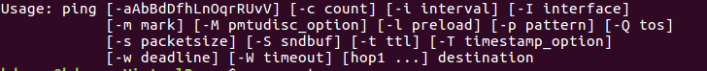

1.To stop pinging use **ctrl+c**

2. To stop pinging after some time use **-w** option – [-w timeout]

3. To send packets as soon as possible use **-f** option

4. We can fill data in packet using **-p** option

5. We can send required packets to **-s** using

**Traceroute:**

This command used to show up the route that will takes the packets to the host. It will be useful when you want to know about the route and about all the hops that a packet takes.

For example: this command is used to reach website(IP Address) host from the local machine and it also prints detail about all the hops that it has visited.

Syntax: traceroute [options] Host Address [pathlength]

Help messages in Traceroute:

**–help**: Display help messages and exit

1. **Command:** traceroute --help

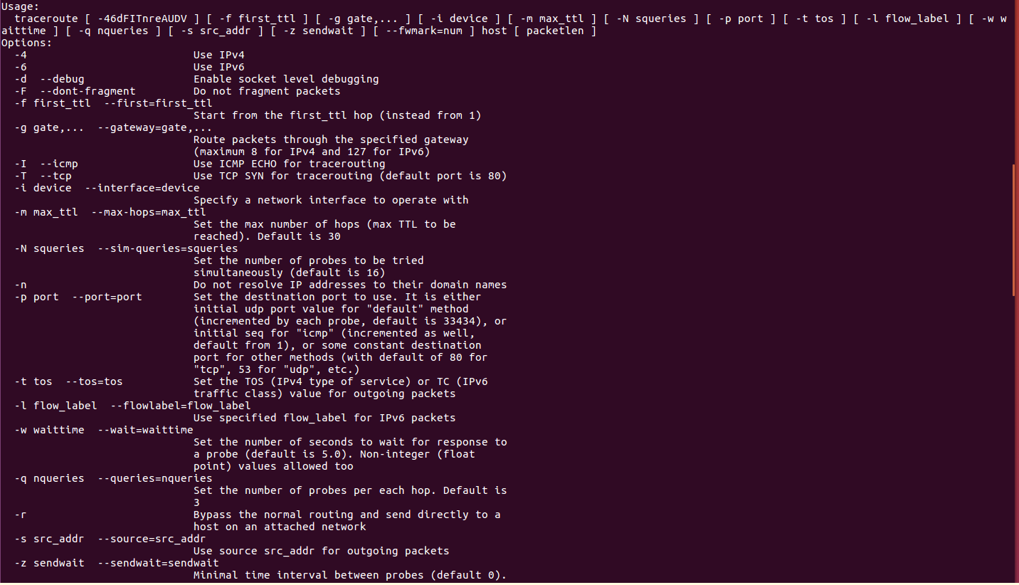

**Man:**

This command is used to display the user manual of any command that can be run on the terminal. It provides overview of the command which includes name, synopsis, description, various versions, options, exit, etc.

Syntax: man [option]

**Manual is divided into sections:**

1. shell commands

2. System calls (by the kernel)

3. Library calls (within libraries)

4. Games

5. Special files

6. File formats and conventions

7. Miscellaneous (including macro packages)

8. System administration commands (root commands)

9. Kernel routines [Nonstandard

Ex:

1. **printf** command

* **$ man printf**
* This command will prints and format the data

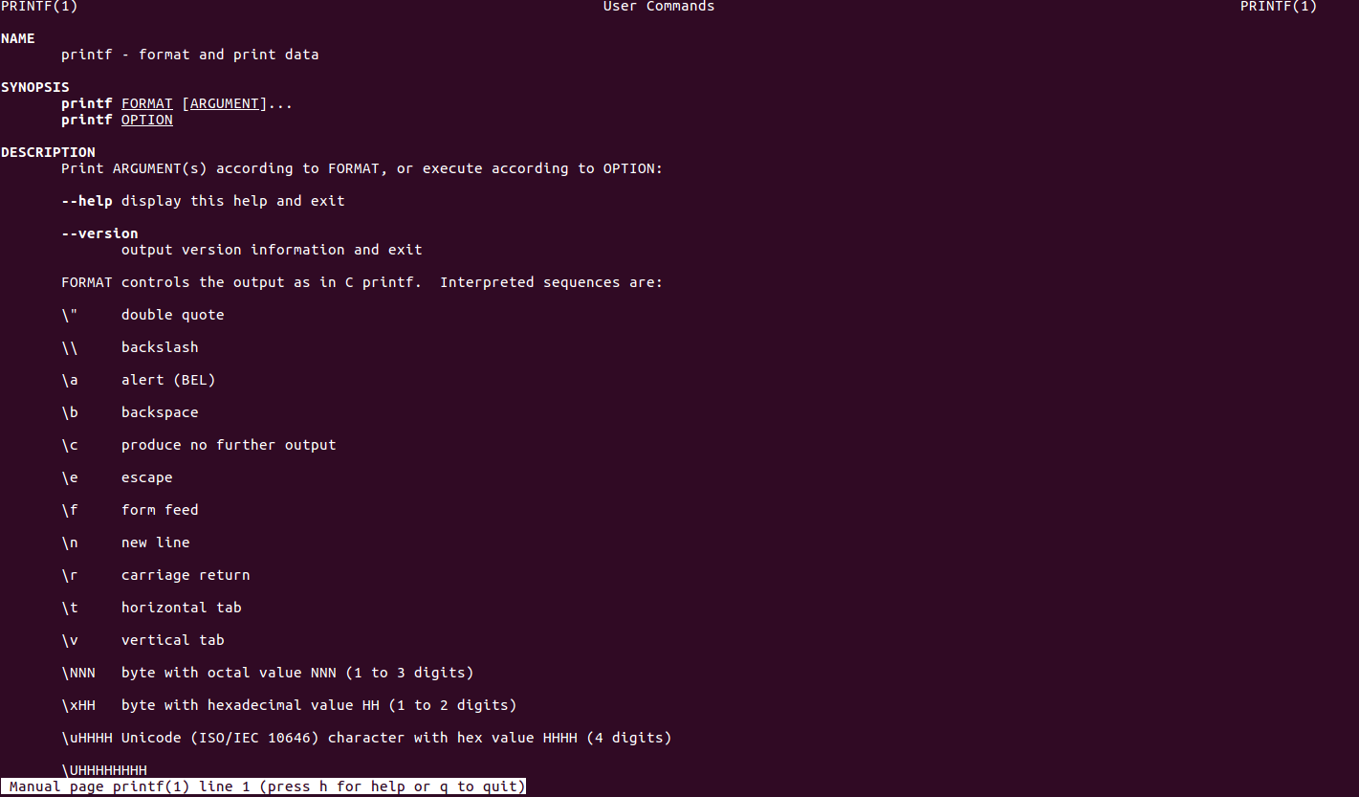

1. **-a option:** This option will help to display all the available intro manual pages.

* **$ man -a intro**

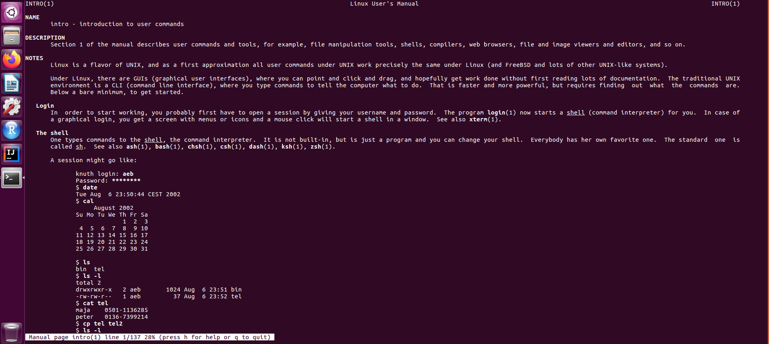

1. **-f option:** This option helps us to if anyone might not be able to remember the sections in which a command is present.

* **$ man -f ls**

**Whatis:**

This command is used to get a one-line manual page descriptions. It will search for the manual page names and show the descriptions of the specified filename. This command will throw an error if any arguments or filenames are passed.

Syntax: whatis [option].. [keyword]..

Ex:

1. **-h option**: The help option will gives the various options that can be used.

* **whatis -h**

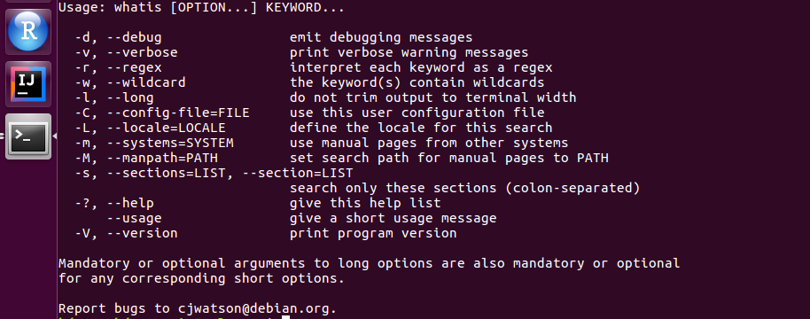

1. **-d option**: used for debugging information

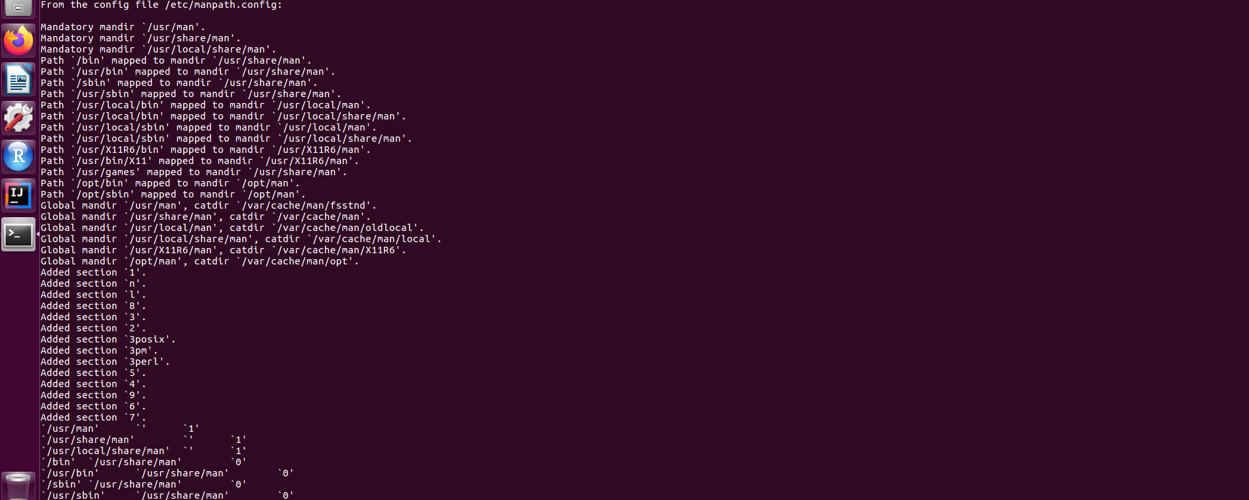

1. **whatis –usage:** This option will get the usage options in whatis.

* **whatis --usage**

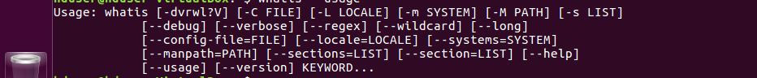

**Su:**

This command is used to run a command as a different user. We can be able to run a function as a different user. Many of users will use **su** to temporarily act as a root user.

Syntax: su [options]

For Ex:

1. **su -h:** It will show up some options for su.

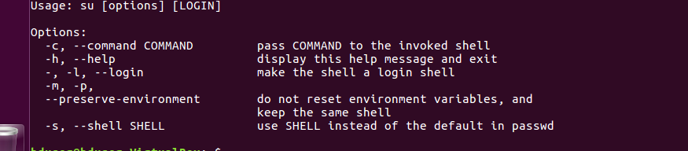

1. **su -l “new user”:** To switch the logged-in user in this terminal window

**Sudo:**

This command allows a user with proper permissions to execute a command as another user. By default, sudo requires that users authenticate with a password which is the user’s password.

**Commands in sudo:**

1. **sudo -V:** This command gets the versions of sudoers
2. **sudo -h:** This option gets all the info of sudo
3. **sudo -l:** Thisoption will print out the commands allowed the user on the current host.
4. **sudo -s:** This option runs the shell specified by the shell environment variable